## *Math for Game Programmers:*

# Solving Nintendo's CodinGame Challenge

## Mike Acton

## [macton@insommiacgames.com](mailto:macton@insommiacgames.com)

## GDC’17

About *process* not solution.

Walkthrough the test code and versions created while solving the problem.

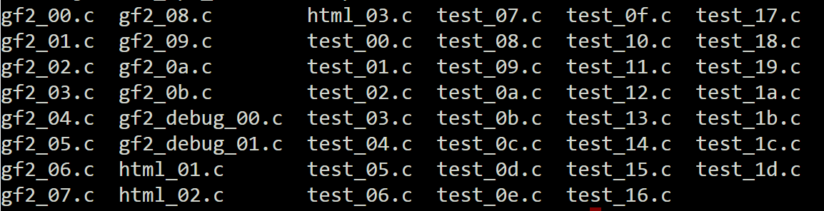

# test_00.exe: test_00.c

What’s the problem?

<https://www.codingame.com/ide/puzzle/nintendo-sponsored-contest>

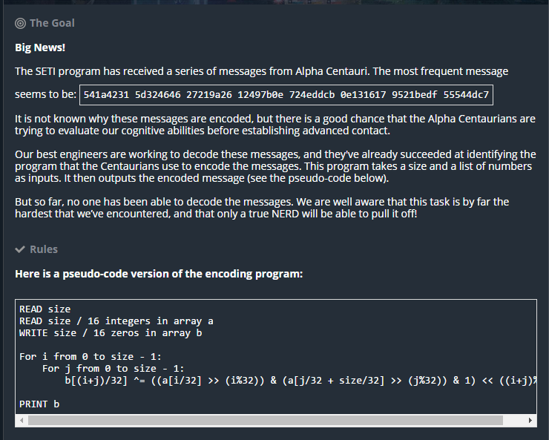

Summarize the problem:

1. B = f(A)
2. Given B and f, return all A which satisfy.
3. Where B is 64, 128, 256 or 512 bits.

Call f, “encode”

* B = encode(A)
* {A0,…,An} = decode(B)

Can assume it’s *possible*.

e.g.

== TEST CASE 4 ==

IN:

64

f3268b49 661859eb 0b324559 65ee6bda

OUT:

0cf5c2bf 9aba68ef c18fb79b de70eef7

c18fb79b de70eef7 0cf5c2bf 9aba68ef

**Q: What does encode do?**

Test encode() with random ints

* rand_ints.h: Get random ints from random.org
* test_00.c: print encoded

# test_01.exe: test_01.c

Test for simple correlation (between bits)

* p(Bn|An) = p(Bn)p(An)/p(An)
* test_01.c : print

First few bits, last few bits are interesting.

* Went off on a tangent: state machine generator
* That’s the really long way around this problem!
* But then…

# test_02.exe: test_02.c

Test encode() with *ordered* values

* test_02.c : increment input value, print results

First impression: Something like a gray code?

# test_03.exe: test_03.c

Maybe something a little more “natural” for me…

* test_03.c : display little endian

Definitely something in the powers-of-two input values…

# test_04.exe: test_04.c

Definitely something in the powers-of-two input values…

* test_04.c : print only the powers of two

Looks like:

uint32_t a[2];

uint64_t b;

if (a[1] & (a[1]-1)) == 0)

{

b = a[0] << ctz(a[1])

}

# test_05.exe: test_05.c

Q: What’s happening when a[1] is *not* a power of two?

* test_05.c: Pick single value (0x0f), show along with all results for each power of two in that value.

Aha! Ok, have a theory! (xor across the set)

# test_06.exe: test_06.c

Visualize steps

* test_06.c: same as test_05.c, just different spacing.

# test_07.exe: test_07.c

Q: Does the theory hold up across all the sample data?

Q: Does the value of a[0] change things?

* test_07.c: create alternate encode2_32() to compare results against rand_ints

ALL TESTS PASSED!

# test_08.exe: test_08.c

Reformulate encode2_32()

These are equivalent:

**test_07.c:**

for (int i=0;i<32;i++)

{

if (a0 & (1<<i))

{

c ^= a1 << i;

}

}

**test_08.c:**

for (int i=0;i<32;i++)

{

c ^= (a0 & (1<<i)) * a1;

}

ALL TESTS PASSED!

# test_09.exe: test_09.c

Re-visualize all the steps against the rand test data.

* Test_09.c : Same as test_07.c but encode2_32() prints steps

Looks suspiciously like a kind of long-hand multiplication!

But for each place…

* = &

+ = ^

**\* 0 1**

**0** 0 0

**1** 0 1

**+ 0 1**

**0** 0 1

**1** 1 0

Q: What fits this model?

A: multiplication of **polynomial over GF(2)** fits *perfectly***.**

GF = **Galois** (ɡaˈlwa) **Field**

GF(2) = **finite field** of two elements

<https://en.wikipedia.org/wiki/GF(2)>

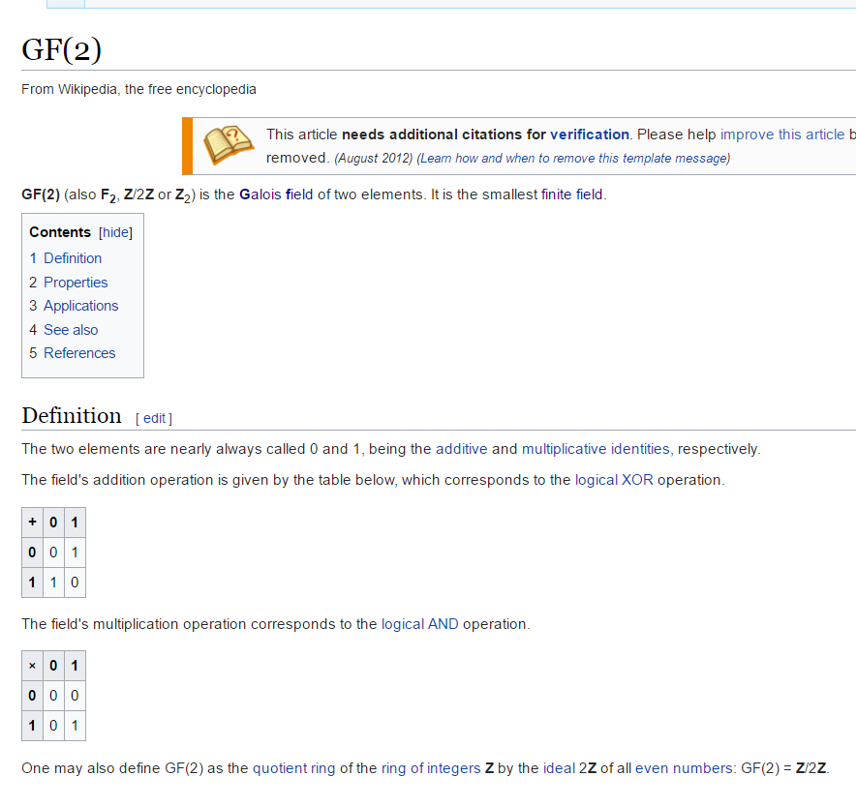

As programmers, we use finite fields all the time.

e.g.

uint8_t a = 0xff;

What is a+2?

i.e.

Just wraps around a certain finite number of things (mod)

GF(2) = mod 2

Nice overview:  
<http://www.math.umn.edu/~garrett/coding/Overheads/08_crcs.pdf>

Q: But what does it mean that it represents a *polynomial* over GF(2)?

1. Exponent is implicit in place
2. Coefficient is stored (can only be one or zero)

e.g.

1011 = 1x^3 + 0x^2 + 1x + 1

1011 = x^3 + x + 1

# test_0a.exe: test_0a.c gf2_00.c gf2.h

Rewrite as gf(2) polynomial multiply

* gf2_00.c
  + p_gf2_mul
  + p_gf2_add
  + p_gf2_sll
* test_0a.c
  + Same as test_09.c but call p_gf2_mul

ALL TESTS PASSED!

# test_0b.exe: test_0b.c gf2_00.c gf2.h

So far assumed:

* a[0] = 32 bits
* a[1] = 32 bits
* b = 64 bits

But also need to verify cases where:

* b = 128 bits
* b = 256 bits
* b = 512 bits

test_0b.c

* Same as test_0a.c, but extend tests to above cases.
* Same random values, just interpreted as different sizes

ALL TESTS PASSED!

# test_0c.exe: test_0c.c gf2_01.c gf2.h

Q: If encode is p_gf2_mul, what does decode do?   
 i.e. What’s the reverse of multiply?

A: Factor

Have another look at each provided test case…

== TEST CASE 1 ==

IN:

32

000073af 00000000

OUT:

00000001 000073af

00000083 000000e5

000000e5 00000083

000073af 00000001

== TEST CASE 2 ==

IN:

32

738377c1 00000000

OUT:

00000001 738377c1

0000b0c5 0000cd55

0000cd55 0000b0c5

738377c1 00000001

== TEST CASE 3 ==

IN:

32

46508fb7 6677e201

OUT:

b0c152f9 ebf2831f

ebf2831f b0c152f9

== TEST CASE 4 ==

IN:

64

f3268b49 661859eb 0b324559 65ee6bda

OUT:

0cf5c2bf 9aba68ef c18fb79b de70eef7

c18fb79b de70eef7 0cf5c2bf 9aba68ef

Print test cases as polynomials.

* test_0c.c
  + print all provided test cases
* gf2_01.c
  + add debugging print p_gf2_print

**Compare:**

== TEST CASE 1 ==

IN:

32

000073af 00000000

OUT:

00000001 000073af

00000083 000000e5

000000e5 00000083

000073af 00000001

== TEST CASE 1 ==

IN:

32

x^14 + x^13 + x^12 + x^9 + x^8 + x^7 + x^5 + x^3 + x^2 + x + 1

OUT:

(1) (x^14 + x^13 + x^12 + x^9 + x^8 + x^7 + x^5 + x^3 + x^2 + x + 1)

(x^7 + x + 1) (x^7 + x^6 + x^5 + x^2 + 1)

(x^7 + x^6 + x^5 + x^2 + 1) (x^7 + x + 1)

(x^14 + x^13 + x^12 + x^9 + x^8 + x^7 + x^5 + x^3 + x^2 + x + 1) (1)

**Verify (Mathematica):**

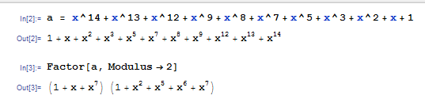

**Verify other test cases:**

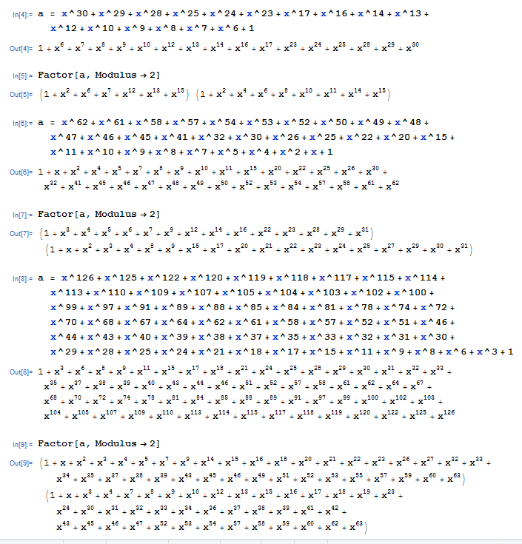

# test_0d.exe: test_0d.c gf2_01.c gf2.h

Restate problem:

***Given a polynomial over GF(2^n) where n={64,128,256,512} display all pairs of factors of degree <= n/2***

Q: What if more than two factors?

A: Combine and test for fit.

Step 1: Find all irreducible factors of f

Step 2. Find all (a,b) which satisfy constraints.

Step 3. Format and sort results

Step 4. Output

So… How to factor polynomials over GF(2)?

WWKD?

*What would Knuth do?*

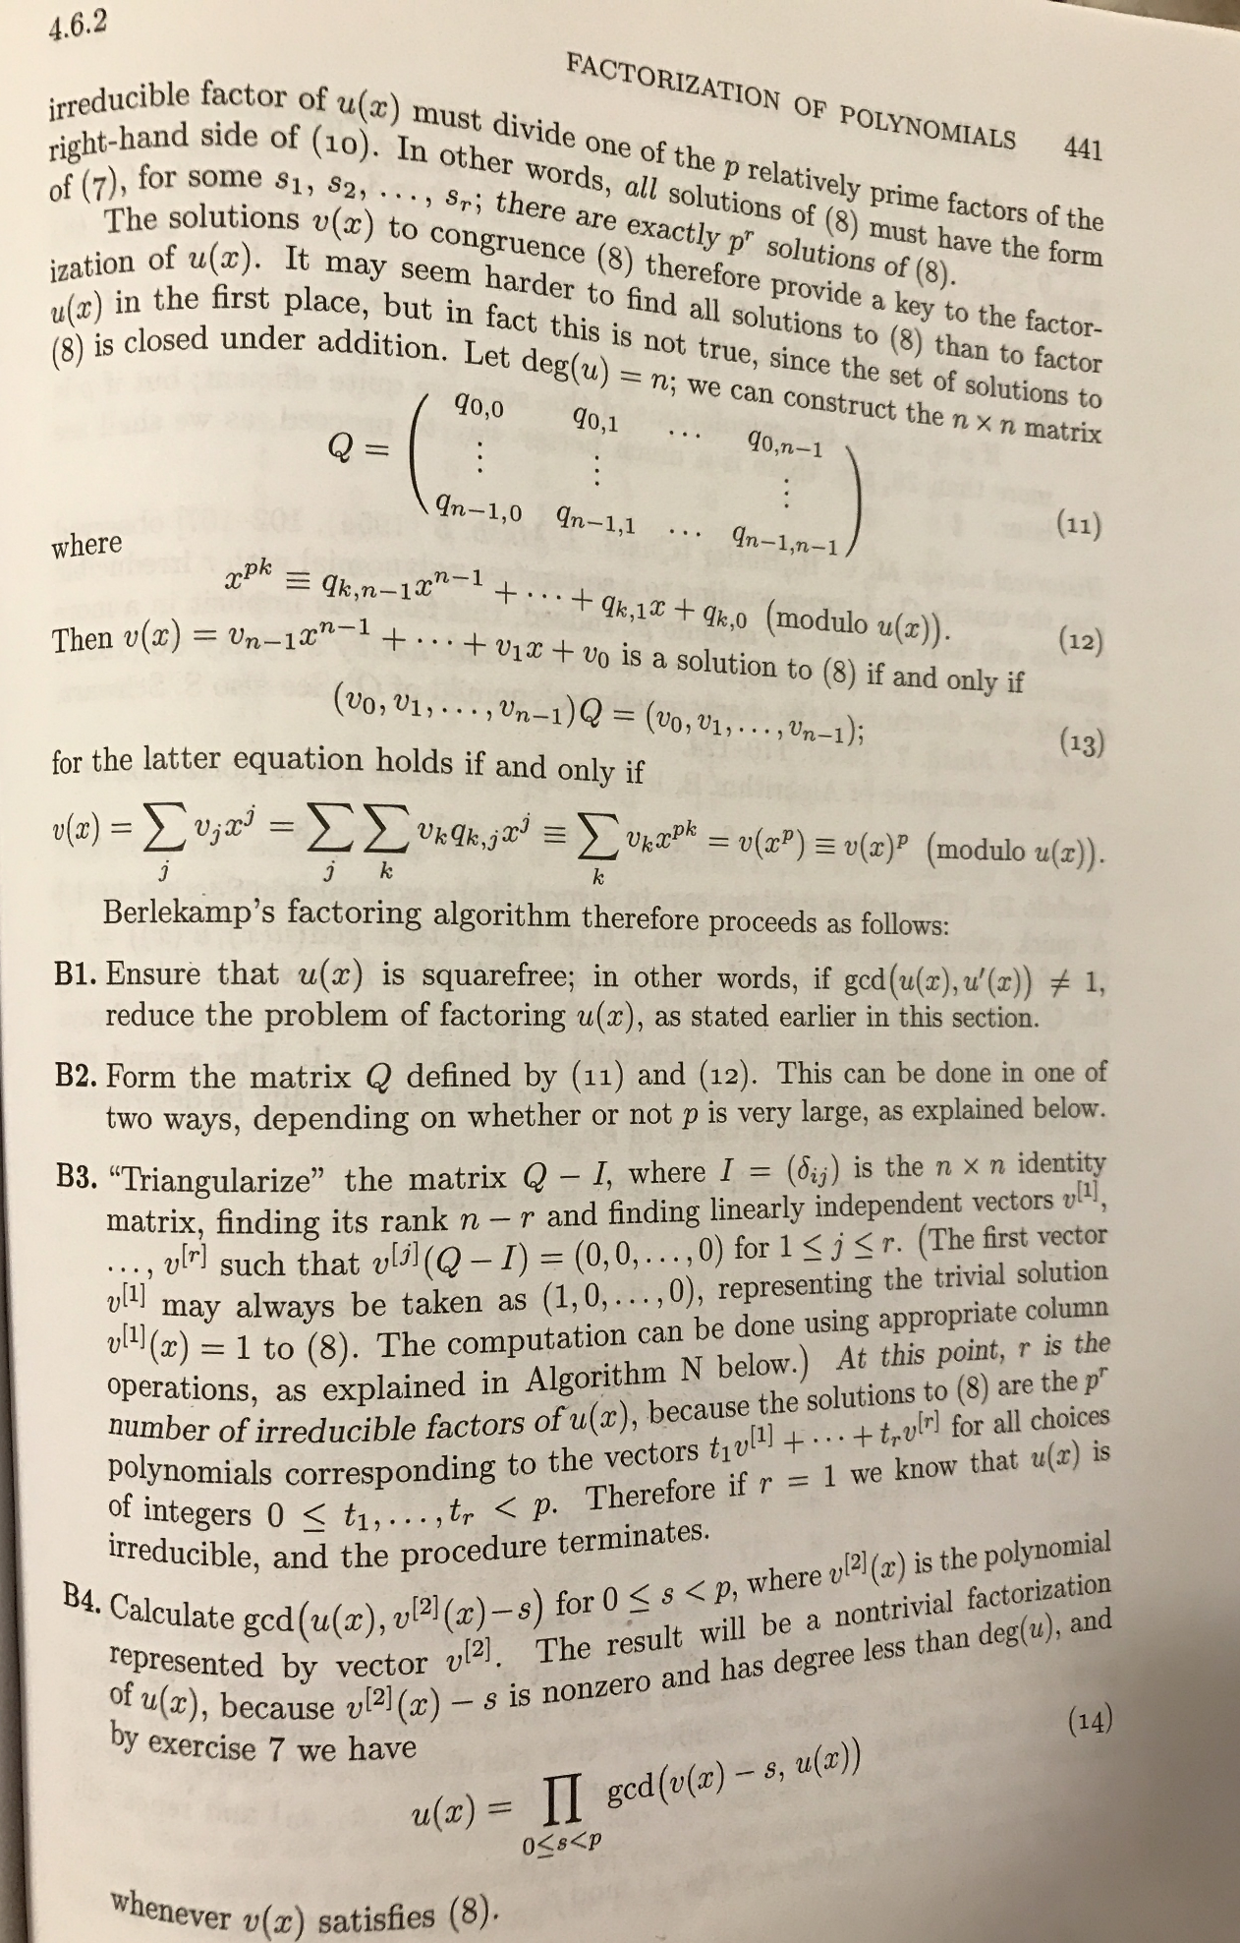

Volume 2 AoCP

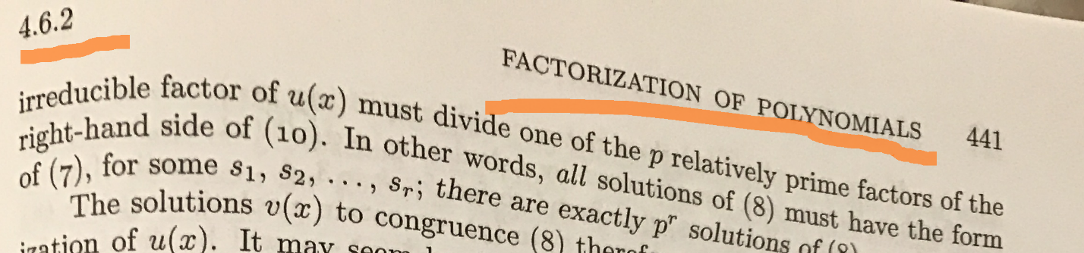

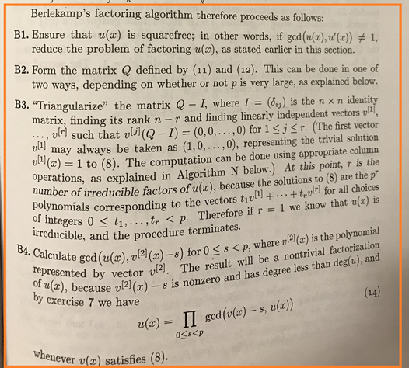

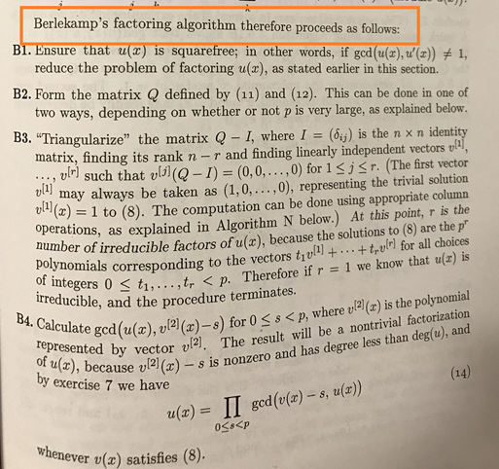

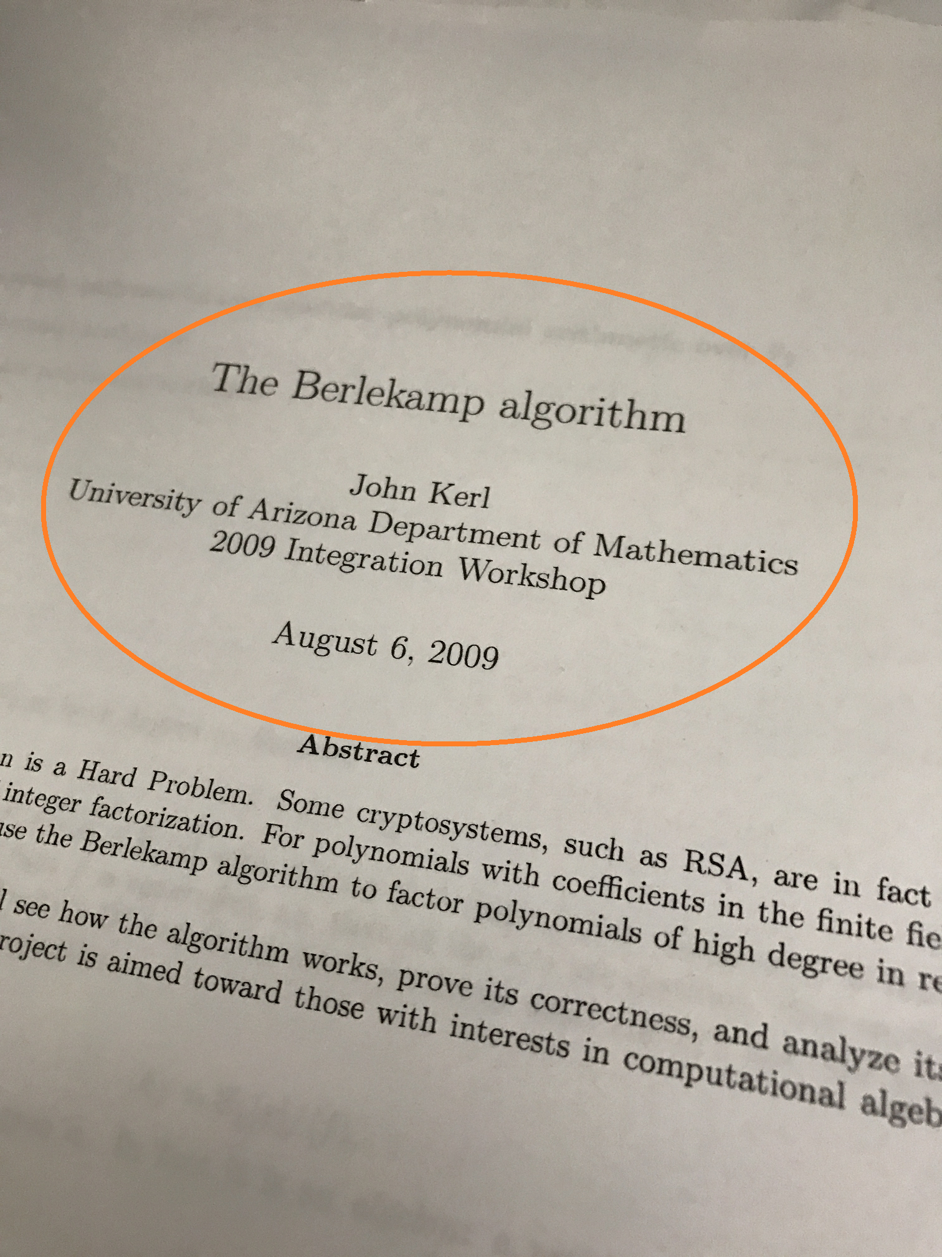

<http://johnkerl.org/doc/iw2009/berlekamp.pdf>

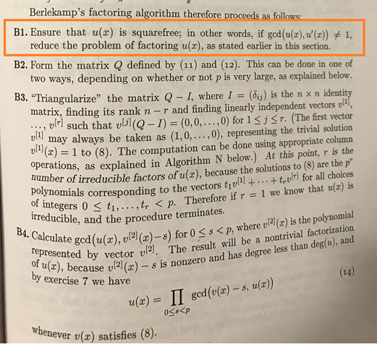

Square-free Factorization

u(x) has square factor if...

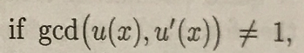

So, to factor out any factor that is a square:

1. f = u(x)
2. f’
3. g=gcd(f,f’)
4. f=gh
5. h=f/g

Create an example with a square in it…

f = b0000110010101110101000111111010001111111111000000000000000110011  
f = 0x0caea3f47fe00033  
f = x59 + x58 + x55 + x53 + x51 + x50 + x49 + x47 + x45 + x41 + x40 + x39 + x38 + x37 + x36 + x34 + x30 + x29 + x28 + x27 + x26 + x25 + x24 + x23 + x22 + x21 + x5 + x4 + x + 1

Verify:

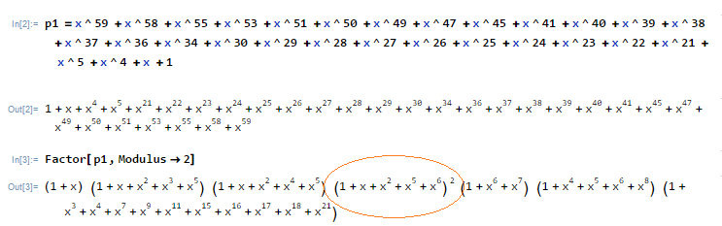

Pull out square factor:

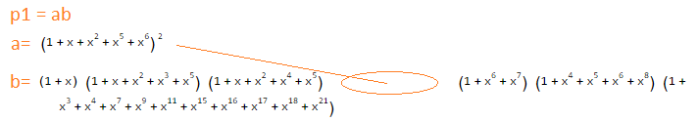

* (1+x) = (0x3)
* (1+x+x^2+x^3+x^5) = (0x2f)
* (1+x+x^2+x^4+x^5) = (0x37)
* (1+x^6+x^7) = (0xc1)
* (1+x^4+x^5+x^6+x^8) = (0x171)
* (1+x^3+x^4+x^7+x^9+x^11+x^15+x^16+x^17+x^18+x^21) = (0x278a99)

Multiply back together.

* test_0d.c: multiply these factors together to get b.

b = x^47 + x^46 + x^45 + x^44 + x^42 + x^41 + x^40 + x^39 + x^38 + x^36 + x^35 + x^32 + x^29 + x^26 + x^23 + x^20 + x^19 + x^18 + x^17 + x^16 + x^15 + x^14 + x^13 + x^12 + x^9 + x^8 + x^5 + x^4 + x^3 + x^2 + x + 1

b = 0x249ff33f 0x0000f7d9

**Verify:**

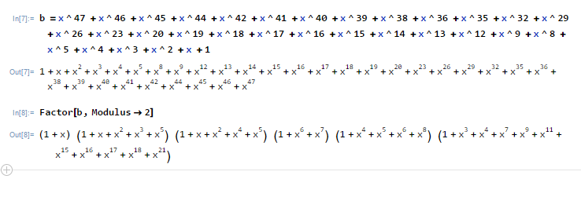

What we should have after SFF:

a = (1 + x + x^2 + x^5 + x^6)^2

b = x^47 + x^46 + x^45 + x^44 + x^42 + x^41 + x^40 + x^39 + x^38 + x^36 + x^35 + x^32 + x^29 + x^26 + x^23 + x^20 + x^19 + x^18 + x^17 + x^16 + x^15 + x^14 + x^13 + x^12 + x^9 + x^8 + x^5 + x^4 + x^3 + x^2 + x + 1

or…

a = (0x67)^2

b = 0x249ff33f 0x0000f7d9

# test_0e.exe: test_0e.c gf2_02.c gf2.h

SFF:

1. f = u(x)
2. f’ <- NEXT STEP
3. g=gcd(f,f’)
4. f=gh
5. h=f/g

Taking the derivative in GF(2)…

Review regular process…

d/dx [x^2 + x + 1] = 2x + 1

But over GF(2) (where 2 = 0):

d/dx [x^2 + x + 1] = 1

gf2_02.c

* p_gf2_derivative

test_0e.c

* print test

(Looks okay…)

# test_0f.exe: test_0f.c gf2_03.c gf2.h

SFF:

1. f = u(x)
2. f’
3. g=gcd(f,f’) <- NEXT STEP
4. f=gh
5. h=f/g

Q: How to GCD of polynomial over GF(2)?

A: Same as GCD of polynomial, only the coefficient math is in GF(2).

Review GCD (Euclid’s Algorithm)

gcd(a,b) = gcd(b,a mod b)

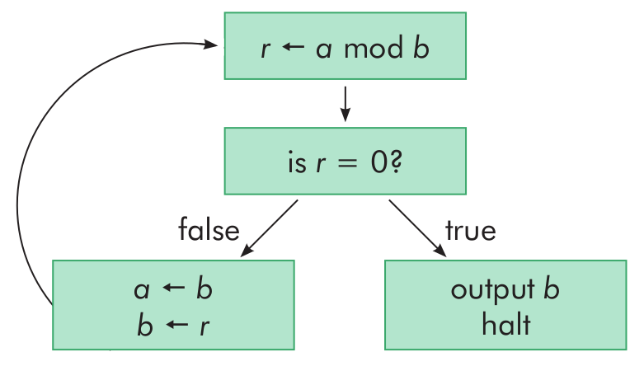

<https://medium.com/great-moments-in-computing-history/euclid-s-ancient-recipe-53e77ba2337c#.xwpnxdpu2>

But (a mod b) implies…

Polynomial division over GF(2)

Q: How to divide polynomial over GF(2)?

A: Same as divide polynomial, only the coefficient math is in GF(2).

Review regular polynomial long division:

e.g.

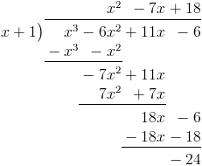

Visualized another way…

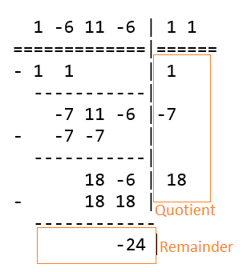

Two operations among coefficients to divide:

1. Multiply
2. Subtract

Multiply coefficients in GF(2) (and):

**\* 0 1**

**0** 0 0

**1** 0 1

Subtraction (mod 2):

0-0 = 0

0-1 = -1 %2 = 1

1-0 = 1

1-1 = 0

Subtract coefficients in GF(2):

**- 0 1**

**0** 0 1

**1** 1 0

Subtraction is same as addition (xor).

Worked example…

c = a/b

a = b00000000000000000001010000010101

a = 0x00001415

a = x^12 + x^10 + x^4 + x^2 + 1

b = b00000000000000000000000001100111

b = 0x00000067

b = x^6 + x^5 + x^2 + x + 1

1010000010101 | 1100111

- 1100111 | 1

------------- |

110111010101 |

- 1100111 | 1

------------- |

100110101 |

- 0000000 | 0

- 0000000 | 0

- 1100111 | 1

------------- |

10101001 |

- 1100111 | 1

------------- |

1100111 |

- 1100111 | 1

------------- |

0 |

a/b = b00000000000000000000000001100111

a/b = 0x00000067

a/b = x^6 + x^5 + x^2 + x + 1

a%b = b00000000000000000000000000000000

a%b = 0x00000000

a%b = 0

test_0f.c

* Print worked example

gf2_03.c

* p_gf2_div
* p_gf2_div_print

# test_10.exe: test_10.c gf2_03.c gf2.h

Return to GCD…

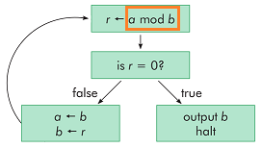

test_10.c

* print gcd(f,f’)

gf2_03.c

* p_gf2_gcd

**Output:**

f = b0000110010101110101000111111010001111111111000000000000000110011

f = 0x0caea3f47fe00033

f = x^59 + x^58 + x^55 + x^53 + x^51 + x^50 + x^49 + x^47 + x^45 + x^41 + x^40 + x^39 + x^38 + x^37 + x^36 + x^34 + x^30 + x^29 + x^28 + x^27 + x^26 + x^25 + x^24 + x^23 + x^22 + x^21 + x^5 + x^4 + x + 1

f' = b0000010001010101010100010101000000010101010100000000000000010001

f' = 0x0455515015500011

f' = x^58 + x^54 + x^52 + x^50 + x^48 + x^46 + x^44 + x^40 + x^38 + x^36 + x^28 + x^26 + x^24 + x^22 + x^20 + x^4 + 1

gcd = b0000000000000000000000000000000000000000000000000001010000010101

gcd = 0x0000000000001415

gcd = x^12 + x^10 + x^4 + x^2 + 1

**Verify:**

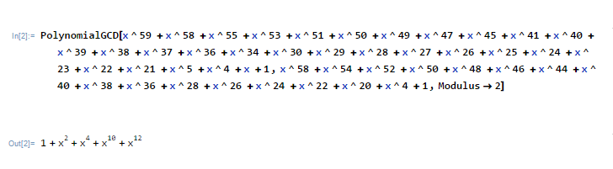

# test_11.exe: test_11.c gf2_04.c gf2.h

SFF:

1. f = u(x)
2. f’
3. g=gcd(f,f’)
4. f=gh <- OK
5. h=f/g <- OK

gf2_04.c

* p_gf2_sff

test_11.c

* print square-free factors

a = b0000110010101110101000111111010001111111111000000000000000110011

a = 0x0caea3f47fe00033

a = x^59 + x^58 + x^55 + x^53 + x^51 + x^50 + x^49 + x^47 + x^45 + x^41 + x^40 + x^39 + x^38 + x^37 + x^36 + x^34 + x^30 + x^29 + x^28 + x^27 + x^26 + x^25 + x^24 + x^23 + x^22 + x^21 + x^5 + x^4 + x + 1

sff(a) = = b0000110010101110101000111111010001111111111000000000000000110011

sff(a) = = 0x0caea3f47fe00033

sff(a) = = x^59 + x^58 + x^55 + x^53 + x^51 + x^50 + x^49 + x^47 + x^45 + x^41 + x^40 + x^39 + x^38 + x^37 + x^36 + x^34 + x^30 + x^29 + x^28 + x^27 + x^26 + x^25 + x^24 + x^23 + x^22 + x^21 + x^5 + x^4 + x + 1

sff(a,0) = (x^6 + x^5 + x^2 + x + 1)^2

sff(a,1) = x^47 + x^46 + x^45 + x^44 + x^42 + x^41 + x^40 + x^39 + x^38 + x^36 + x^35 + x^32 + x^29 + x^26 + x^23 + x^20 + x^19 + x^18 + x^17 + x^16 + x^15 + x^14 + x^13 + x^12 + x^9 + x^8 + x^5 + x^4 + x^3 + x^2 + x + 1

sff(a,0) = (b1100111)^2

sff(a,1) = b111101111101100100100100100111111111001100111111

sff(a,0) = (0x67)^2

sff(a,1) = 0xf7d9249ff33f

**Q: Is this what we expected?**

(from test_0d) What we should have after SFF:

a = (1 + x + x^2 + x^5 + x^6)^2

b = x^47 + x^46 + x^45 + x^44 + x^42 + x^41 + x^40 + x^39 + x^38 + x^36 + x^35 + x^32 + x^29 + x^26 + x^23 + x^20 + x^19 + x^18 + x^17 + x^16 + x^15 + x^14 + x^13 + x^12 + x^9 + x^8 + x^5 + x^4 + x^3 + x^2 + x + 1

or…

a = (0x67)^2

b = 0x249ff33f 0x0000f7d9

# test_12.exe: test_12.c gf2_05.c gf2.h

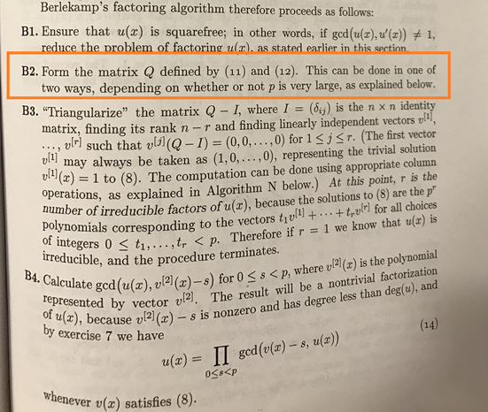

Re: The “explained below…”



To summarize results:

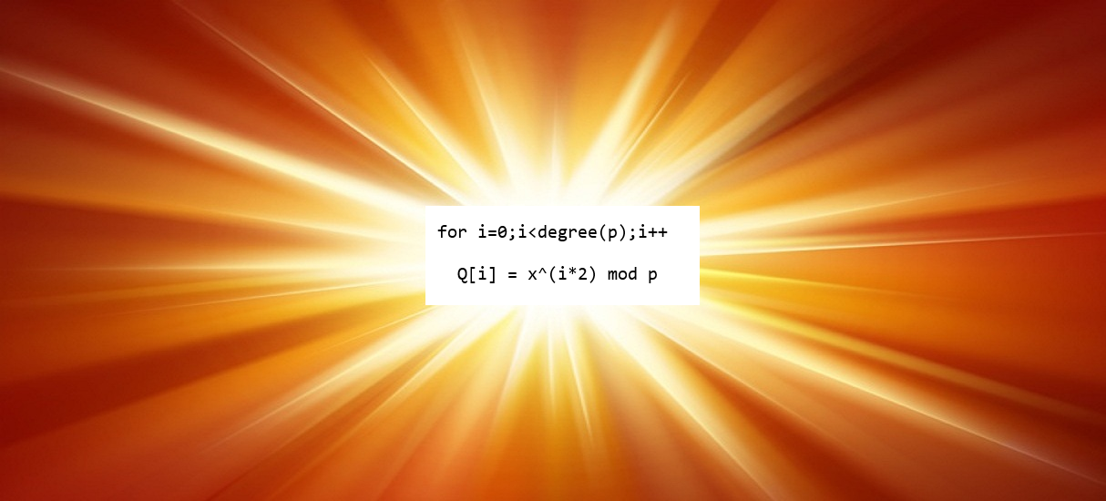

for i=0;i<degree(p);i++

Q[i] = x^(i*2) mod p

Example from <http://johnkerl.org/doc/iw2009/berlekamp.pdf>

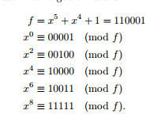

test_12.c

* Verify same results from Kerl’s example.

# test_13.exe: test_13.c gf2_05.c gf2.h

Start with a simple example with two irreducible factors to verify as we go:

(1+x+x^2+x^4+x^5) = (0x37)

(1+x^6+x^7) = (0xc1)

Multiply together:

a = (1+x+x^2+x^4+x^5)(1+x^6+x^7)

a = (0x37)(0xc1)

Result:

a = b00000000000000000001011001110111

a = 0x00001677

a = x^12 + x^10 + x^9 + x^6 + x^5 + x^4 + x^2 + x + 1

test_13.c

* Multiply and print this example

# test_14.exe: test_14.c gf2_05.c gf2.h

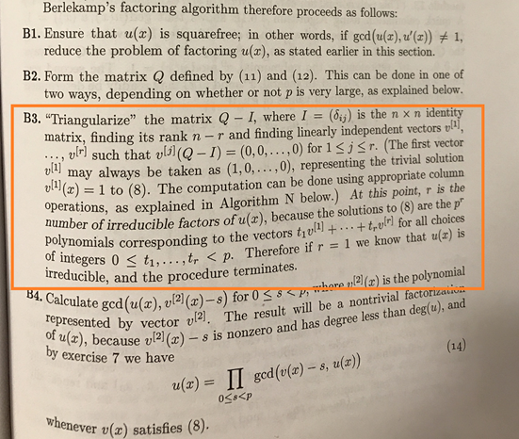

**B3 Summary**

1. M = Q-I
2. Find null basis vectors of M

**B3:**

1. M = Q-I
2. Find null basis vectors of M

test_14.c

* Print Q, I, M (for example from test_13)

# test_15.exe: test_15.c gf2_06.c gf2.h

**B3:**

1. M = Q-I
2. Find null basis vectors of M

Excellent walkthrough here: <http://math.stackexchange.com/questions/1612616/how-to-find-null-space-basis-directly-by-matrix-calculation/1612994#1612994>

To summarize:

1. Augment M with identity (I) of same size
2. Transform M in row-reduced echelon form (rref)
3. Null basis vectors are where left side of augmented form is zero.

**B3:**

1. M = Q-I
2. Find null basis vectors of M
   1. Augment M with identity (I) of same size
   2. Transform M in row-reduced echelon form (rref)
   3. Null basis vectors are where left side of augmented form is zero.

W = Augment M with I:

W[i] = (M[i] << deg(a)) | (1 << i)

test_15.c

* Create W; Print W

# test_16.exe: test_16.c gf2_07.c html_01.c gf2.h html.h

**B3:**

1. M = Q-I
2. Find null basis vectors of M
   1. Augment M with identity (I) of same size
   2. Transform M in row-reduced echelon form (rref)
   3. Null basis vectors are where left side of augmented form is zero.

*Gauss-Jordan Elimination*

* Useful description:  
  <http://pages.pacificcoast.net/~cazelais/251/gauss-jordan.pdf>
* Calculator for reference:   
  <http://matrix.reshish.com/gauss-jordanElimination.php>

rref:

* gf2_07.c
  1. p_gf2_rref
  2. p_gf2_rref_html
* test_16.c
  1. index.html: print all rref steps to verify

W = 100000001001 000111100000

010000001000 011011011100

001000000000 000101010110

000100000001 000100100100

000010000000 001100010010

000001001000 000000001000

000000101000 011011111100

000000010001 000100110100

000000000101 000100110000

000000000011 000100110010

000000000000 111111010100

000000000000 000000000001

Print in easy to paste into Mathematica form:

w = {{0,0,0,0,0,0,0,0,0,0,0,0,0,0,0,0,0,0,0,0,0,0,0,1},{0,0,0,0,0,0,0,0,0,1,1,0,0,0,0,0,0,0,0,0,0,0,1,0},{0,0,0,0,0,0,0,1,0,1,0,0,0,0,0,0,0,0,0,0,0,1,0,0},{0,0,0,0,0,1,0,0,1,0,0,0,0,0,0,0,0,0,0,0,1,0,0,0},{0,0,0,1,0,0,0,1,0,0,0,0,0,0,0,0,0,0,0,1,0,0,0,0},{0,1,0,0,0,0,1,0,0,0,0,0,0,0,0,0,0,0,1,0,0,0,0,0},{0,1,1,0,0,0,1,1,0,1,1,1,0,0,0,0,0,1,0,0,0,0,0,0},{1,1,1,1,0,0,1,0,1,0,1,1,0,0,0,0,1,0,0,0,0,0,0,0},{0,1,0,1,0,0,1,1,0,1,0,1,0,0,0,1,0,0,0,0,0,0,0,0},{0,1,0,0,1,0,1,0,0,0,1,1,0,0,1,0,0,0,0,0,0,0,0,0},{1,0,0,0,1,1,1,1,1,0,1,1,0,1,0,0,0,0,0,0,0,0,0,0},{0,0,0,1,0,1,1,1,0,1,0,1,1,0,0,0,0,0,0,0,0,0,0,0}}

Verify with RowReduce[w,Modulus->2]:

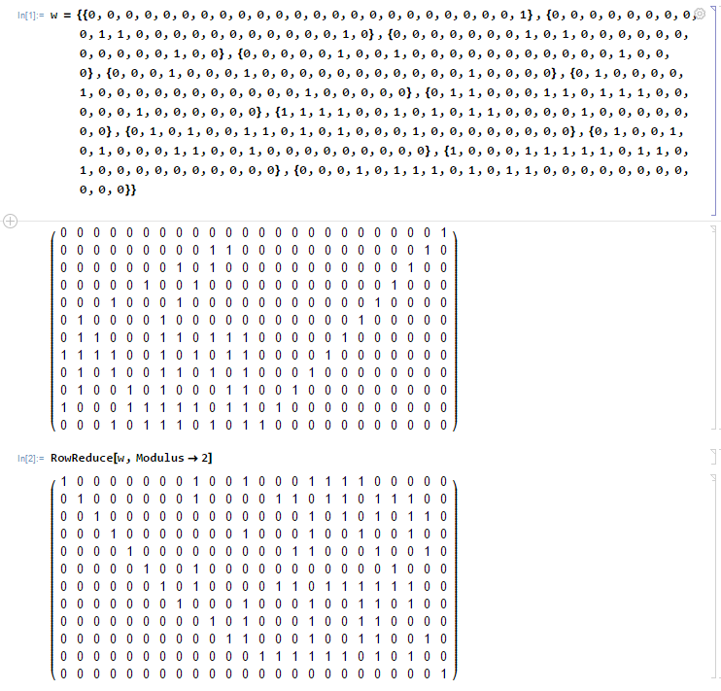

# test_17.exe: test_17.c gf2_07.c html_01.c gf2.h html.h

**B3:**

1. M = Q-I
2. Find null basis vectors of M
   1. Augment M with identity (I) of same size
   2. Transform M in row-reduced echelon form (rref)
   3. Null basis vectors are where left side of augmented form is zero.

test_17.c

* Index.html: Same as test_16, but highlight null basis vectors in W.

# test_18.exe: test_18.c gf2_08.c html_02.c gf2.h html.h

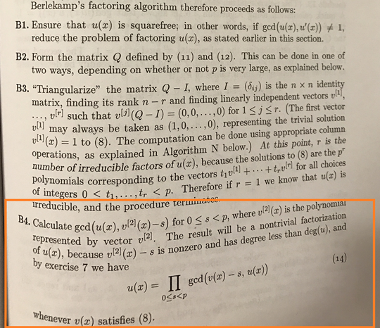

B4 Summary

1. For each non-trivial vector (v) found in B3, find non-trivial factors with:
2. gcd( f, v )
3. gcd( f, v-1 )

From test_17:

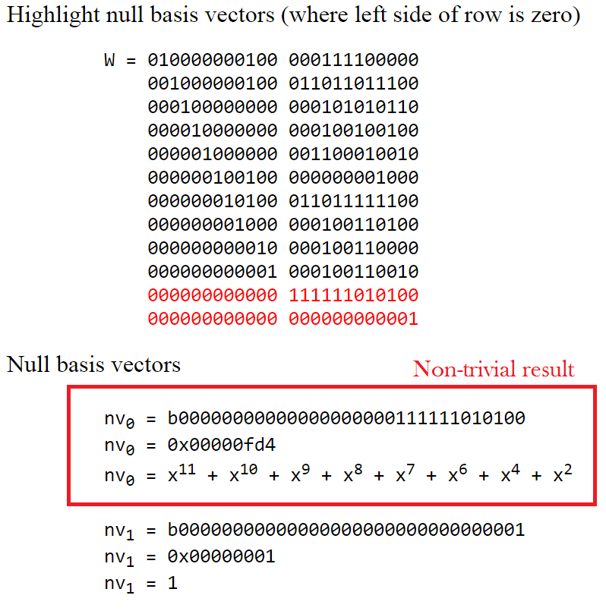

gf2_8.c

* p_gf2_berlekamp_nontrivial_bases: calculation from test_17.c
* filter out trivial one
* p_gf2_berlekamp_nontrivial_bases_html: same, but with html steps output

test_18.c

* Calculate and print:
* gcd( f, v )
* gcd( f, v-1 )

Results from test_18:

bv[0] = b00000000000000000000111111010100

bv[0] = 0x00000fd4

bv[0] = x^11 + x^10 + x^9 + x^8 + x^7 + x^6 + x^4 + x^2

gcd( a, bv[0]+0 ) = b00000000000000000000000000110111

gcd( a, bv[0]+0 ) = 0x000000**37**

gcd( a, bv[0]+0 ) = **x^5 + x^4 + x^2 + x + 1**

gcd( a, bv[0]+1 ) = b00000000000000000000000011000001

gcd( a, bv[0]+1 ) = 0x000000**c1**

gcd( a, bv[0]+1 ) = **x^7 + x^6 + 1**

Q: Is this what we were looking for?

A: Remember from test_13:

Start with a simple example with two irreducible factors to verify as we go:

(1+x+x^2+x^4+x^5) = (**0x37**)

(1+x^6+x^7) = (**0xc1**)

Yay! Solved a *simple* example.

# test_19.exe: test_19.c gf2_08.c html_02.c gf2.h html.h

Test on our larger (square-free) example from test_0d:

Remember:

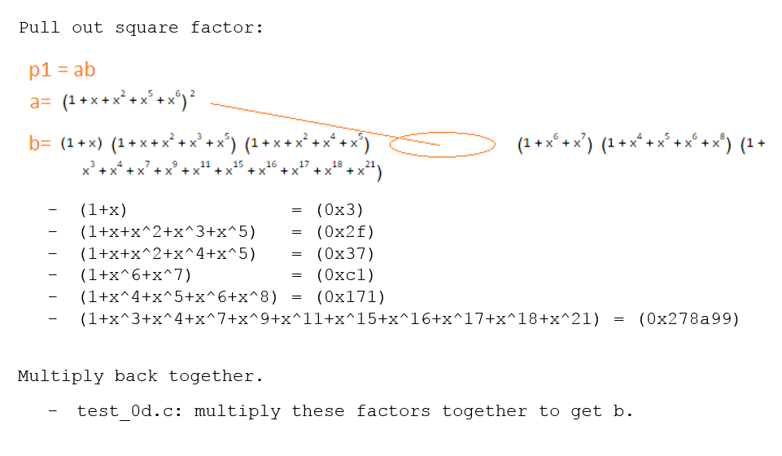

a = b0000000000000000111101111101100100100100100111111111001100111111  
a = 0x0000f7d9249ff33f  
a = x47 + x46 + x45 + x44 + x42 + x41 + x40 + x39 + x38 + x36 + x35 + x32 + x29 + x26 + x23 + x20 + x19 + x18 + x17 + x16 + x15 + x14 + x13 + x12 + x9 + x8 + x5 + x4 + x3 + x2 + x + 1

test_19.c

* Same as test_18.c but with (a), index.html: Print non-trivial factors

# test_1a.exe: test_1a.c gf2_08.c html_02.c gf2.h html.h

Stick with the same example:

a = b0000000000000000111101111101100100100100100111111111001100111111  
a = 0x0000f7d9249ff33f  
a = x47 + x46 + x45 + x44 + x42 + x41 + x40 + x39 + x38 + x36 + x35 + x32 + x29 + x26 + x23 + x20 + x19 + x18 + x17 + x16 + x15 + x14 + x13 + x12 + x9 + x8 + x5 + x4 + x3 + x2 + x + 1

Need factors to actually multiply to get a.

Steps:

For each non-trivial factor (f)

if ( (a%f) == 0 )

a = a / f

add f to list of final non-trivial factors of a

test_19.c

* Same as test_18.c, but add steps above to get a list of non-trivial factors which can be multiplied to get a.

Result from test_1a:

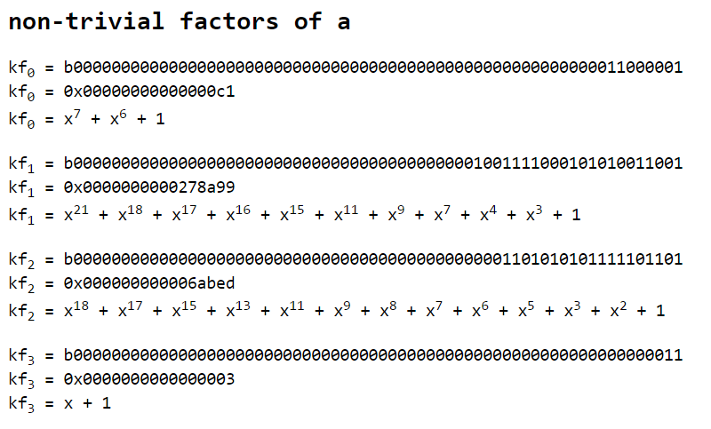

**Non-trivial factors != irreducible factors**

# test_1b.exe: test_1b.c gf2_09.c html_02.c gf2.h html.h

Q: How to get irreducible factors from non-trivial factors?

A: Recurse!

Steps:

1. For each f in the list of non-trivial factors,
2. Find non-trivial factors of f,
3. Until none can be found.

gf2_09.c

* p_gf2_berlekamp_nontrivial_factors: Calculation from test_1a.c
* p_gf2_berlekamp_nontrivial_factors_html: Same, but output steps to html

test_1b.c

* Loop over non-trivial factors until none can be found.

Results from test_1b:

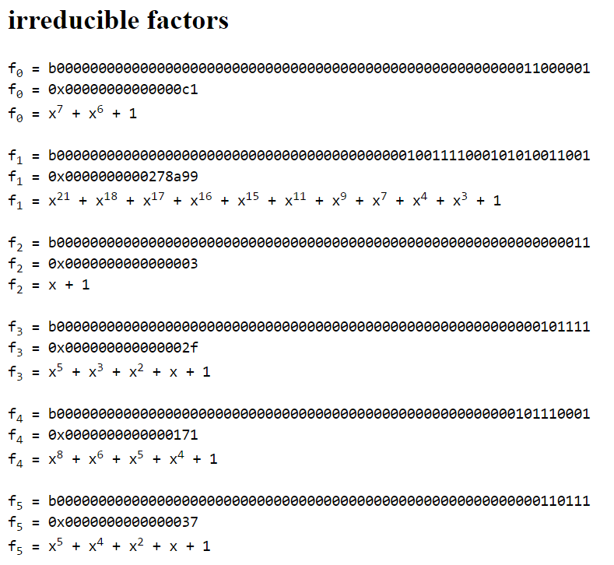

Is this what we expected? (from test_0d):



Yay!

# test_1c.exe: test_1c.c gf2_0a.c gf2_debug_00.c html_03.c gf2.h html.h

Go back to a polynomial with squares in it…

Remember from test_0d:

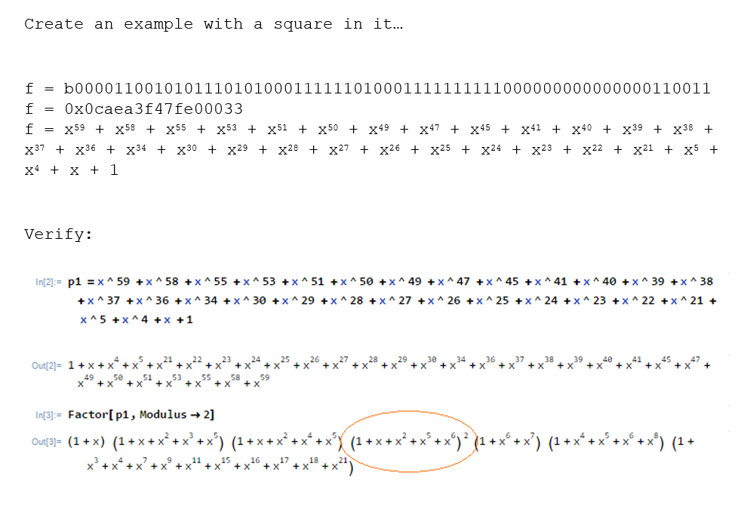

test_1c.c

* call p_gf2_sff first.
* For each square-free factor, same as test_1b.c (find list of irreducible factors)
* Combine to final list.

Results from test_1c

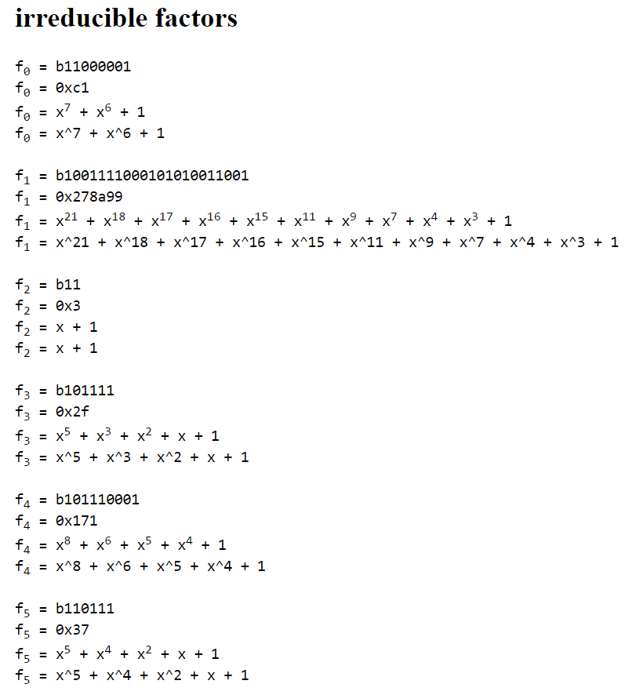

Same!

# test_1d.exe: test_1d.c gf2_0b.c gf2_debug_01.c html_03.c gf2.h html.h

From test_1c:



Want to get factors fully expanded.

* Just add to final factor list as many times as exponent.

gf2_0b.c

* p_gf2_factor: Roll in calculation from test_1c.c, duplicate squared factors.
* p_gf2_factor_html: Same but print steps to html

test_1d.c

* Print expanded factors

Excellent!

Back to the original problem…

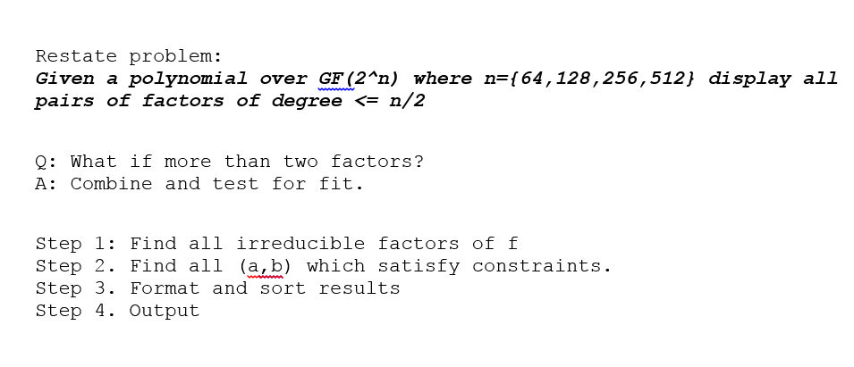

# test_1e.exe: test_1e.c gf2_0b.c gf2_debug_01.c decode_00.c html_03.c gf2.h html.h decode.h

decode_00.c

* decode
  + Step 2. Find all (a,b) which satisfy constraints.
  + Step 3. Format and sort results
  + Step 4. Output
* decode_html
  + Same as above, but outputs steps to html

test_1e.c

* Same as test_1d, but decode to final output format.

# test_1f.exe: test_1f.c gf2_0b.c gf2_debug_01.c decode_00.c html_03.c gf2.h html.h decode.h

test_1f.c

* Run against original test cases.

e.g.

== TEST CASE 3 ==

IN:

32

46508fb7 6677e201

OUT:

b0c152f9 ebf2831f

ebf2831f b0c152f9

Result:

==== TEST 3 ====

b0c152f9 ebf2831f

ebf2831f b0c152f9

OK!

But *sometimes* in the original test cases, the results include an (unnecessary) factor with 1.

== TEST CASE 1 ==

IN:

32

000073af 00000000

OUT:

00000001 000073af

00000083 000000e5

000000e5 00000083

000073af 00000001

Q: When to include the 1 factor in the results?

A: *The solution to that is left as an exercise to the reader. ;)*